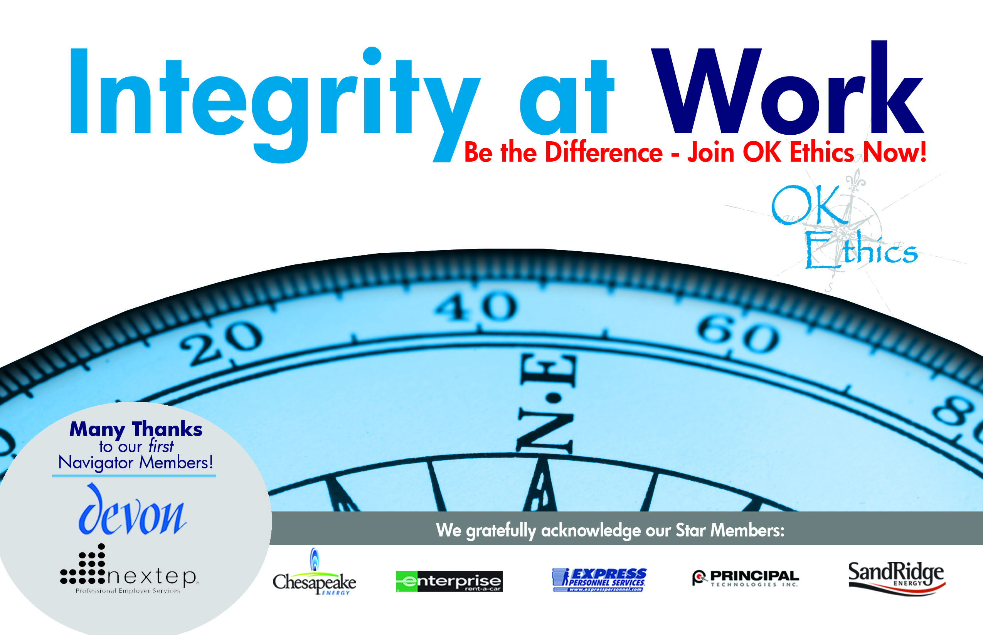
OKLAHOMA BUSINESS ETHICS CONSORTIUM
Oklahoma City Chapter ~ October 10, 2007

- KUDOS Shannon Hiebert, Vice President of Human Resources, Enterprise-Rent-A-Car & President of OkEthics
Guiding Principle: HONOR We express gratefulness to our hosts, sponsors and speakers.
  - Janice Dobbs of Devon Energy for her initiative in becoming OKETHICS’ first Navigator ($7500) member!
  - Buck Irwin & Brian Fayak with Nextep for being NORMAN’s FIRST NAVIGATOR member!
  - Kelli Schneider for actual “hands-on” development of our new marketing materials – including this past weekend. Kelli was recently appointed to the OkEthics Board of Directors by a unanimous vote!
  - Greg Byers – Sinclair Broadcasting Group – Registration Chair – Epitomizes diligence & dependability!
  - Mary Kay Huggard & the Principal Technologies team for their dedication & availability in handling the registrations!
  - Blaine Rider, now in the real estate business while maintaining his connections with Digital West, has agreed to provide photos of our meetings for our new online photo gallery.
  - Tess Smith with Walker Companies for cleaning and storing our new banner – then magically making it reappear each month.
  - Joshua Jantz for his dependability in preparing and organizing our name tags every month.
  - Connie Barwick – Maximum Multi Media Creations for the pre-meeting Power Point presentations, bookkeeping and website expertise.
  - Behind the scenes, our dedicated volunteers who serve on the Board and keep the organization running!

- MEMBERSHIP DRIVE IS UNDERWAY!
NAVIGATOR – $7,500 Includes 16 memberships; prepaid for all OkEthics events – including annual Compass Award.
STAR - $5,000 Includes 8 memberships; prepaid for all OkEthics events – including
annual Compass Award

INDIVIDUAL MEMBERSHIP LEVELS:
Scout = $ 75 (Individual membership, no meals)
Trailblazer = $750 (Includes 1prepaid meal)

GROUP MEMBERSHIP LEVELS:
Horizon - $2,500 (includes 8 prepaid meals)
Leading - $1,200 (includes 2 prepaid meals) Frontier - $ 350 (8 memberships; no meals)

- MEMBER TESTIMONIAL - Norman’s FIRST NAVIGATOR MEMBER: NEXTEP
Brian Fayak, CEO & President, Nextep ~ Compass Award Recipient – April, 2007

- ETHICS DISCUSSION - Marian Combs, Dean of OBU International Graduate School

OkEthics Guiding Principle - Respect:
- Members may become aware of confidential information shared by others in an effort to determine an ethical course of action. We ask members to be sensitive in recognizing and respecting the efforts made toward achieving ethical behavior. In that vein, public disclosure of this information is discouraged.
- We respect other members and the process by:
- Exhibiting listening skills and actively listening to discussion
- Being open to other points of view and outcomes
- We are an inclusive organization and demonstrate this by welcoming members who are in different stages of learning as applied to ethical behavior.

A new office opens, and managers and support staff move files from one location to another. A spacious reception area includes cabinets stocked with office supplies. During the first month, an entire box of file folders disappears during evening hours. In response, the secretarial manager institutes a “locked door” policy for office supplies, requiring all staff, including managers, to ask the receptionist to unlock cabinets in order to access any office supplies. Evening workers are often in the office beyond official reception hours, and so, are unable to access supplies. Many begin purchasing supplies with their own money rather than go through the hassle of formal requests for supplies.
NOTE: Members of the Oklahoma Business Ethics Consortium frequently share information concerning various issues and developments that may have legal implications. The discussions, commentary, and handouts at Consortium meetings or presentations to other organizations are for general informational purposes only. They cover only some aspects of the subject topic, and do not constitute a complete legal analysis of the topic or how it might apply to any particular set of facts. Before taking any action based on information presented by a Consortium member, participants are encouraged to consult a qualified attorney. The observations and comments of presenters at Consortium meetings and networking are the views and opinions of the presenter and do not constitute the opinion or policies of the Consortium or any of its members.

1. Discuss the ethical implications of the office supply control policy.
2. Think of specific examples in your own work life of the tension between accountability and empowerment,and effects of both on ethics, employee morale, and productivity. Be prepared to share the best example from your table. Please do not use specific company/people names.

Note – Handouts will be available as you exit today’s meeting. Feel free to use this case study in promoting discussions at work.

- SPEAKER INTRODUCTION: Brent Gooden, The Gooden Group

- KEYNOTE SPEAKER: Burns Hargis, Vice Chairman of Bank of Oklahoma

VII. UPCOMING EVENTS Shannon Warren, OkEthics Founder & Acting Director
Advance reservations required for all events ~
Visit our website at www.okethics.org or call 858-2233;
Member discounts apply regardless of location.

Norman Chapter
October 17 – David Rhoades, Fraud & Forensics Investigations -
“When Ethics Breaks Down – Now It’s Fraud”
***RECOMMENDED FOR 1 CPE CREDIT***

OKC Chapter
- November 14 – Scott Pruitt, General Managing Partner,
Oklahoma RedHawks; “The Business of Sports”

- December 12 – (Not posted yet - tentative) Panel to discuss psychological impact of culture on individual behavior – “How Good People Turn Evil”

- January 8, 2008 - Lindy Ritz, Director of the Mike Moroney Aeronautical Center (FAA)

- March 12, 2008 – “Religion’s Impact on Ethical Decision-Making in the Workplace”
Panel of clerics lead by moderator, Dr. Vince Orza, Dean of Meinders School of Business, OCU; confirmed Dr. Bob Long from St. Luke’s Methodist Church; Rabbi Russell Fox and others invited ~ stay tuned!
Tulsa Chapter
- October 25 - Greg Stubblefield, President of Vanguard Car Rental

OTHER RELATED PROGRAMS:

Character First Institute -

Oklahoma City Business and Community Leaders' Breakfast and Luncheon
Would you like to enhance morale, strengthen coworker relationships, create a positive learning environment, and lead with integrity? Join us at the monthly Business and Community Leaders' Breakfast and Luncheon. Now is the time for character-based solutions in our communities. If not now, when? If not us, whom? If not through character, how?

Topic: Determination in the Workplace
Determination vs. Faintheartedness
Purposing to accomplish right goals at the right time, regardless of the opposition

Registration Information
Dates:
Luncheon; Thursday, October 25, 2007—12 P.M. to 1 P.M.
RSVP Required by October 18; Call 815-0001
Cost: $10
PLEASE HELP US CONTROL COSTS BY LEAVING YOUR NAME TAG HERE!

